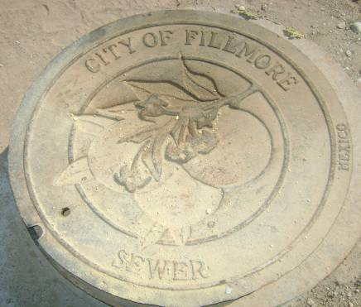  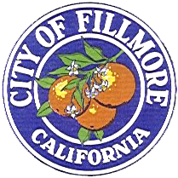 | 2010 Project of the Year Award  APWA Ventura County Chapter

Project Name
City of Fillmore Water Recycling Program

Project Location
Water Recycling Plant located at 1580 River Street in Fillmore, California and reuse sites throughout the City.

Award Category
The total construction cost of the Program was approximately $70 million. This project is being submitted under the “Environment” Category.

Project Overview
Since 1955, the City of Fillmore treated wastewater at a plant that was permitted to discharge effluent to the Santa Clara River. However, more stringent discharge limitations imposed by the Los Angeles Regional Water Quality Control Board threatened the continued operation of the City’s wastewater treatment plant in its current state. The City decided that the best solution was to replace the old wastewater treatment plant with a new, state-of-the-art water recycling facility that would end the practice of river discharges and enable full-scale reuse. What has resulted is a project that goes far beyond wastewater treatment and encompasses water conservation, recreation, education, transportation, entertainment, environmental preservation, sustainability, and quality of life for the City of Fillmore and County of Ventura.

Management Techniques
The City retained AECOM (formerly Boyle Engineering Corporation) to compile a Project Report which entailed defining current and future wastewater flows (quality and quantity), analysis of effluent reuse and disposal opportunities for various levels of treatment, conceptual design of the new Water Recycling Facilities, detailed cost and schedule projections, and evaluation of alternative project delivery systems for the various project components. As the project progressed the City expanded AECOM’s responsibilities to include Program Management involving assistance with permitting, CEQA compliance, right-of-way resolution, funding, FEMA processing, and agency-type construction management.
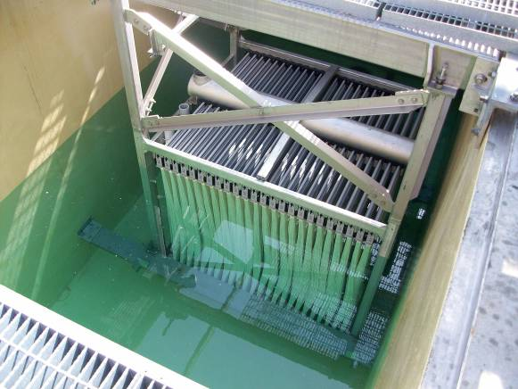
The Project Report identified wastewater treatment alternatives for the City of Fillmore and recommended Membrane Bioreactor (MBR) treatment to meet the water quality and environmental-improvement goals of the City. This resulted in the design and construction of a zero-discharge water recycling facility that will produce recycled water to be used within the City. Currently, zero-discharge water recycling facilities are uncommon in coastal environments especially where a river is nearby, so this project is somewhat of a trendsetter.
The City of Fillmore Water Recycling Program also offers a high technical value because it presents a new way of looking at a traditional engineering deliverable. Instead of focusing merely on wastewater treatment and discharge, the Program Management Approach broadened the scope to maximize benefits to the entire City. An analysis of the domestic water system was conducted to determine if domestic water treatment would resolve water quality issues affecting discharge options. The introduction of the water recycling system in Fillmore also led to opportunities for numerous upgrades to public-use facilities and grant opportunities.
Installation of Membranes at Treatment Plant
The new Water Recycling Program was not contracted by the traditional design-bid-build approach, but rather by a combination of delivery systems. The design-build-operate delivery model, which represents the future of engineering in many respects, was used for the Water Recycling Plant. The design-build-operate team (American Water, Lyles Construction, and Kennedy/Jenks Consultants) has a 20-year contract with the City, which still owns the plant. Benefits realized with design-build-operate include timely and cost-efficient scheduling, optimal risk allocation, competitive design selection, clear assignment of performance responsibilities to a single contracting entity, long-term facility operational and maintenance efficiencies, and overall cost savings. The plant itself is leading edge, with MBR technology and ultraviolet (UV) disinfection used to deactivate bacteria and viruses in the effluent. UV disinfection leaves no residual in the treated effluent that can affect reuse of the water.
The design-bid-build delivery system was used for the “non plant” components of the Water Recycling Program. AECOM designed the “non plant” components associated with the Water Recycling Program, including a levee and bike path near the Plant, a bike path linked to the middle school, the basic components of a 20-acre Two Rivers Park, recycled-water and storm water pipelines, and effluent disposal and reuse facilities. The design-bid-build delivery system for these components provided the City the greatest flexibility to manage cost, schedules, risks, and efficiencies of the multi-faceted program.
Finally, the City opted to self-perform the work required to convert existing irrigation systems from potable water supply to recycled water. This approach provided the City and Fillmore Unified School District, (recycled water end user) the opportunity to control costs, schedules, education and training programs, and implement a proactive team effort with park operations, school operations, and other City managed sites.

Environmental Awareness and Enhancements
The entire approach of the City of Fillmore Water Recycling Program is innovative and an enlightened approach with respect to engineering. It’s a multifaceted project that serves the City’s long-term wastewater treatment needs, enables water reclamation for the first time in the City, and has resulted in new recreational opportunities for Fillmore residents.
The Effluent Disposal and Reuse Master Plan called for the widespread use of subsurface drip irrigation systems. This not only places heads and valves out of harm’s way, but also results in greater efficiencies—less evaporation and runoff elimination. So the system can effectively operate 365 days a year during rain, wind or sunshine. The subsurface drip irrigation approach also provides other benefits:
- Maximizes Public Health – since the recycled water is not exposed to the public.
- Maximizes Water Treatment Efficiency – since the natural soils treatment process will further treat the recycled water prior to reentering the ground water system.
- Maximizes water efficiency as subsurface drip systems save 20 to 30% on water useage.
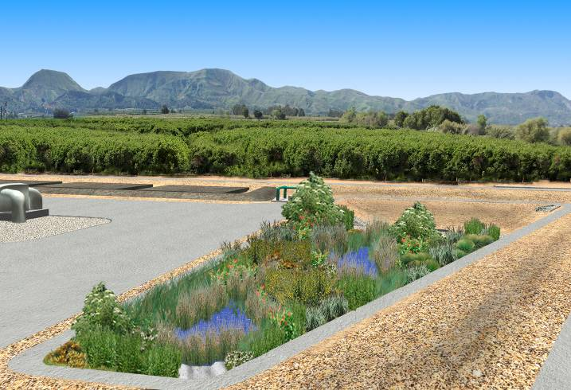
One of the truly innovative ideas of the City of Fillmore Water Recycling Program is the creation of a wetland adjacent to the new zero-discharge treatment facility. The wetland is supplied with treated effluent that first trickles down rocks to increase dissolved oxygen levels in the water. Not only does the wetland provide habitat for California-native vegetation and wildlife, but it also provides further treatment of the effluent. Since nitrogen and phosphorous are essential plant nutrients, they can be removed from the water source by plant uptake. Many trace metals and micronutrients can be taken up by plants as well. All of the original plantings are California native plants and were selected because they are vital to the wetland ecosystem or they can thrive in moist to saturated soils. For instance, the flowers of the Golden Currant attract hummingbirds to the wetland, while the San Diego Sedge helps control erosion. Then there is the Spike Rush, which birds use for nesting, and the submerged portion of the plant offers habitat for micro and macro-invertebrates in the water. The pond contains mosquito fish, which feed on the larvae of mosquitoes.
Rendering of the Onsite Wetland
The following design aspects of the WRP provides for environmental awareness and enhancements:
- The site selection resulted in the City’s treatment facilities being located at the lowest, westerly edge of the City in the business park in lieu of the previous “in town” location adjacent to residential development and City Park facilities. This avoided the need to pump sewage up to the plant had it stayed at the WWTP site.
- The WRP design focused on low electrical usage. The service contract provides the City a guaranteed efficient level of electrical usage. Additionally the Water Recycling Plant is designed for minimizing electrical usage during the day with flow equalization facilities and effluent disposal and reuse operations being maximized after 9:00 pm and before 6:00 am.
- Ultraviolet disinfection was used in lieu of chlorine/sodium hypochlorite to avoid impacts to the already elevated levels of chloride in the region’s ground water.
- The MBR process provides treated effluent that is ten times cleaner than other treatment alternatives considered. The design criteria for the WRP required a level of treatment that exceeds the current requirements set by the Regional Water Control Board.
- The WRP is required to be operated to meet stringent “low noise” levels.
- Additionally the service contract provides the City an “odor guarantee” to assure that objectionable odor levels are not measured at property lines.

Social and Economic Considerations / Community Benefits
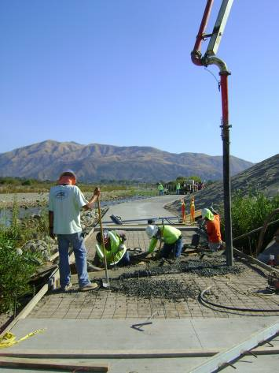
The City of Fillmore’s Water Recycling Program was implemented for the benefits to its citizens. For starters, the new plant is capable of handling increased flows of wastewater as the City grows. The program also brings environmentally compatible water recycling to the City, which helps stretch potable supplies in a City that does not have access to imported water. In addition, the program has led to the construction of new bike paths, a 20-acre park, and citywide landscaping improvements. Furthermore, the project meets Ventura County and the Regional Water Quality Control Board’s goals of reducing chlorides in the Santa Clara River and the Fillmore subunit of the Santa Clara River groundwater basin, over which the project lies.
To educate its citizens about the Water Recycling Program, the City has set up a public-display on a trail near the wetland. The display shows step-by-step details of the water-recycling process, maps out the new recycled-water distribution system, and describes the environmental benefits of the wetland.
As the project unfolded from conceptualization, to design, to construction, and to operations the City held town hall meetings to inform the public about the various aspects of the Water Recycling Program and answer any questions. To assist with information dissemination, guest speakers were brought in to provide expertise. Guest speakers included representatives of the Department of Public Health, the Regional Water Quality Control Board, Ojai Sanitary District, the Las Virgenes Municipal Water District, and other Cities, Sanitary Districts, and industry leaders experienced with recycled water use facilities.
Construction of the Bike Path Along Sespe Creek

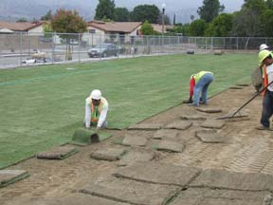
Among the major areas for recycled water use within the City are school grounds, ball fields, parks, and public-access sites. A new park included baseball fields, football/soccer fields, tennis courts, basketball courts, and a skateboard facility. Two new stretches of bike path resulted from this program, one atop a 1,400-foot-long levee that protects the new water recycling facility and business park from flooding and the other linked to Fillmore Middle School. (Note that the levee meets the county, state, and federal standards for a 100-year flood occurrence.) Recycled water for irrigation will be provided to the levee areas to encourage plant growth for slope protection and to provide habitat for wildlife.
This project resulted in the design of new railroad crossings and landscaping along the tracks used by the Fillmore and Western vintage trains that offers lunch and dinner tours of scenic settings in the vicinity, murder-mystery events, etc.
With the new plant in full operation by the design-build-operate team, the old plant is no longer needed and has been demolished to expand the 20 acre Two Rivers Park to 35 acres and make way for additional soccer, play, and baseball fields that will be irrigated with recycled water.
A major side benefit of the City of Fillmore Water Recycling Program is that it helps achieve one or more goals of the CALFED Bay-Delta Program. While the Fillmore Water Recycling Program is outside of the Bay-Delta area, the fact that the project will reduce the City’s need to obtain supplemental water from the Delta via the County of Ventura’s contract with the State Water Project results in more water being left in the Delta, which CALFED can use for its Delta Program.
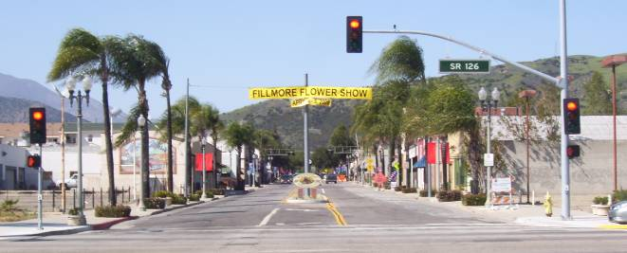
When it was time to develop plans to lay pipelines for recycled water, the project team seized an opportunity to rehab a fifty year old waterline and install a 5-foot-diameter storm water pipeline that ran under Central Avenue in downtown Fillmore. This required considerable coordination to minimize disruption to merchants and citizens, but it allowed a much-needed capital improvement project to be accomplished at the same time as the installation of the recycled-water pipe. Also, a fiber optic line was installed at the same time to connect the individual irrigation systems to a centrally located Supervisory Control and Data Acquisition System. The fiber optic line is also available for fire and police connections.
The City’s program management approach provided the opportunity to support local social and economic goals. The overall project was not handled by a large non-local firm but was effectively and efficiently implemented by the best experts available to add the value to the City’s program, most of which were found locally. The firms included:
- AECOM (Boyle), Ventura, CA – Program Management, “non plant” design services, and agency-type construction management
- American Water – Operator of the Water Recycling Plant
- WM Lyles Construction, Bakersfield, CA – Constructor of the Water Recycling Plant
- Kennedy/Jenks, Ventura, CA – Designer of the Water Recycling Plant
- Hamner Jewel, Ojai, CA – Right-of-Way Services
- Fugro West Ventura, Ca – Geotechnical and Materials Testing
- Hopkins Ground Water, Ventura, Ca – Ground Water Related Services
- AECOM (ENSR), Camarillo, CA – Air Quality Permitting
- L Newman Design Group, Westlake, CA – Landscaping Specialist
- Advanced On-Site, San Diego, CA – SDI Consulting
- Golden State Labor Compliance, Palmdale, CA – Labor Compliance Services
- Benner & Carpenter, Santa Barbara, CA – Surveying
- Hawks & Associates, Ojai, CA – Permeable Weir Design
- Padre Associates, Ventura, CA – Environmental Permitting and Monitoring
- M.J. Schiff & Associates, San Diego, CA – Corrosion
- AECOM (P&D Consultants), Pasadena, CA – CEQA Process, FEMA Process
- Hawkins Delafield & Wood, New York, NY – DBO Contract Preparation Services
- Bear Stearns, Los Angeles, CA – Bond Process Underwriter
- John C Fitzgerald and Associates, Los Angles, CA – Financial Consultant
- Rincon Consultants, Ventura, CA – Environmental Monitoring
- Earth Systems, Ventura, CA – Geotechnical and Materials Testing
- Leighton Group, Inc, Ventura, CA – Geotechnical and Materials Testing
- Jordan Gilbert & Bain, Ventura, CA – Landscape Architects
- Penfield & Smith, Camarillo, CA – Survey Services

Challenges
The City of Fillmore Water Recycling Program is a multifaceted effort that totals slightly less than $70 million. When combined with concurrent construction the total is close to $80 million. It began with preparation of a Project Report in 2004. The Project Report mapped out the overall program and set the stage for the Environmental Impact Report. Following certification of the Environmental Impact Report, the City stated the permitting process with Caltrans, railroad, the Los Angeles Regional Water Quality Control Board, the Dept. of Fish and Wildlife, U.S. Army Corps of Engineers, Ventura County Watershed Protection District, FEMA, Ventura County Air Pollution Control District, California Department of Public Health, and others.
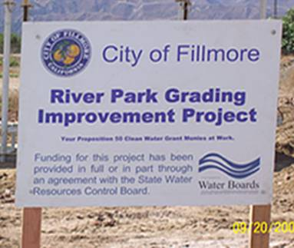
The certification of the EIR allowed the City to start the process of selling municipal bonds and obtain millions in grant funding for the program, including grants from the California State Water Resources Control Board, Federal Emergency Management Agency, Southern California Edison and Caltrans.
The Program required acquisition of rights-of-way and easements/encroachment permits for pipelines, and user agreements with schools, railroad, developers, and private sector for construction and operation of irrigation facilities for disposal of recycled water on school lands.
The RWQCB’s time schedule order set the inflexible schedule. The schedule milestones were achieved. The City identified a budget goal in 2004 and established the not-to-exceed budget in 2006. The 2004 budget expectation and 2006 budget requirements were achieved even with project enhancements and expansions.

Meeting and Exceeding Project Goals
Following are some of the major goals the City of Fillmore established with respect to this project, all of which have been met:
- Provide wastewater treatment capabilities sufficient to meet regulatory requirements and satisfy the demand of City residents through 2025;
- Implement water reclamation throughout the City;
- Protect and improve the region’s water resources;
- Educate the public on the benefits of water recycling; enhance recreational opportunities and the quality of life via project components;
- Achieve cost efficiencies on behalf of ratepayers;
- Over 350,000 manhours of labor expended without a lost time incident;
- Complete WRP prior to the mandated date of operation in the Time Schedule Order; and
- Complete the City’s WRP Program under the budgets set six years earlier.

